|  |
| --- |
| # root (cd $home ) |
| #git clone <https://github.com/ashishrpandey/example-voting-app> |
| #cd /root/example-voting-app/k8s-specifications |
| #kubectl apply -f **.** |
|  |
| 5. For voting and result pods, observe that NodePort is assigned. |
|  |
| 6. Take your publicIP (your instance IP) : NodePort ► open 2 browsers , one for VOTING and one for Results.  7. Try voting and see the results paralelly in results page. |
|  |
| Voting app is ready with the vote percentage. |

=====================================================================================

☝️ After Deletion:  
 ► VOTE pod : Observe what happens both in frontEnd & in Unix

* **In the Backend CLI:**
* New Pod created after the deletion of the **Vote Pod.**

Reason: Replica set to **1** in **vote-deployment.yaml**

apiVersion: apps/v1

kind: Deployment

metadata:

name: vote

spec:

selector:

matchLabels:

app: vote

replicas: 1

* **In the Front End:**

same Container ID which is created at the backend after the deletion also shows in the front end:

****************************************************************

► WORKER pod: Observe what happens both in frontEnd & in Unix

1. Before deletion Worker Pod:



1. After deletion of Worker Pod:

* **In the Backend CLI:**
* New Pod created after the deletion of the **Worker Pod.**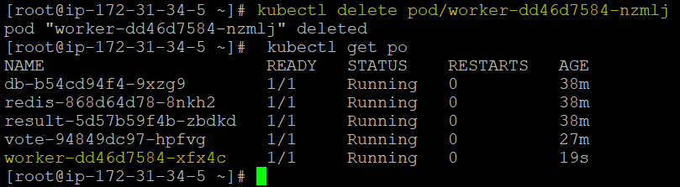
  + **In the Front End:**

No changes can be observed at the front end as worker node details are not visible to the front end.

► **DB pod** : Observe what happens both in frontend & in Unix

1. Before deletion **DB Pod**:

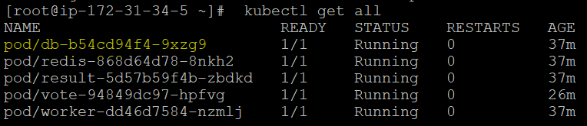

1. After deletion of DB Pod:

* **In the Backend CLI:**
* New Pod created after the deletion of the **DB Pod:**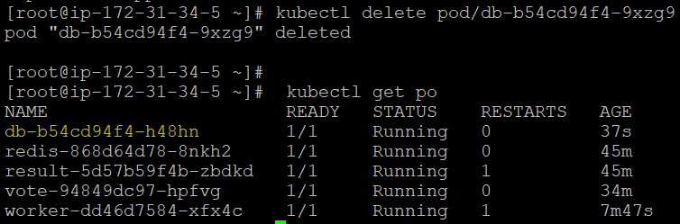
  + **In the Front End:**
* Voting data has been deleted and percentage value.
* As we see at the Front-end, voting percentage values set to default 50% as voting data has been lost after DB Pod deletion.



* As per above observations, we can say that we should not delete the DB pod as it not having any persistent storage.